3D Printed Movable Tactile Pictures for Children with Visual Impairments to Learn Mobility

| 1st Author Name  Affiliation  Address  e-mail address  Optional phone number | 2nd Author Name  Affiliation  Address  e-mail address  Optional phone number | 3rd Author Name  Affiliation  Address  e-mail address  Optional phone number |
| --- | --- | --- |

# ABSTRACT

Paste the appropriate copyright/license statement here. ACM now supports three different publication options:

* ACM copyright: ACM holds the copyright on the work. This is the historical approach.

This text field is large enough to hold the appropriate release statement assuming it is single-spaced in TimesNewRoman 8 point font. Please do not change or modify the size of this text box.

Every submission will be assigned their own unique DOI string to be included here.

Updated 7/30/2014. In this sample paper, Sheridan Printing Co., Inc. describes the formatting requirements for SIGCHI Conference Proceedings, and this sample file offers recommendations on writing for the worldwide SIGCHI readership. Please review this document even if you have submitted to SIGCHI conferences before, some format details have changed relative to previous years.

## Author Keywords

Tactile Pictures; 3D Printing; Fabrication

## ACM Classification Keywords

H.5.m. Information interfaces and presentation

# INTRODUCTION

To develop emergent literacy for children with visual impairments, 3D printing has been considered the most promising method to tactilize visual images of children book. By printing 3D tactile pictures of visualized features, visually impaired children can touch and feel the object, and follow the context of the text, cultivate emergent literacy. However, very small number of artists have been created tactile book manually, so lack of replicability, customizability. Even tactile pictures printed in 3D are missing mobility and interactivity. Therefore, importance of 3D printing for publishing tactile books has been on the rise, and we suggest to add movable pieces of component on 3D printed tactile picture to engage children interact with them.

## Lack of Mobility of 3D Printed Tactile Books

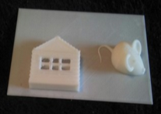 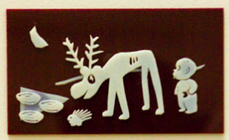

**Figure 1. 3D printed tactile books lack mobility**

We published a series of 3D printed tactile books that visually impaired children can touch and feel. Figure XX shows some pages of 3D printed *Goodnight Moon,* and *Harold and Purple Crayon*. However, unlike interactive books, such as lift-the-flap books, 3D printed pictures are stationary, natural moving attributes are missing. Although distinct shape of object is the most essential factor of good tactile picture, mobility of object takes a significant role to teach attributes of entity in daily life for children can learn from the book. For example, sighed kids flip the slice of a page and learn how to open the door, pull down the slice of another page and learn how the drawer is dragged off. This activity also pokes their intellectual curiosity. Can blind children learn movements of object by 3D printed tactile pictures? Can parents design these books without barrier to technology and customize based on children’s interests and different development level of literacy?

## Lift-the-Flap Books as Interaction Trigger

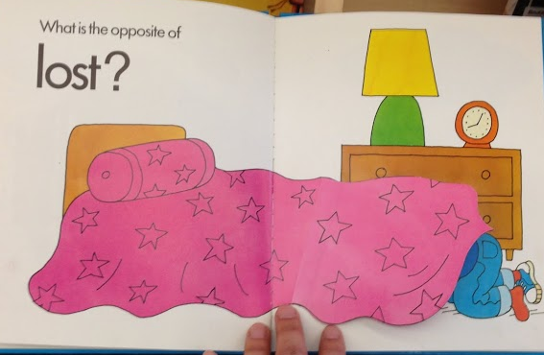 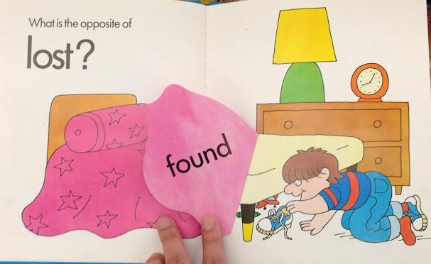

**Figure 2. Images of toys are found behind the comforter, by lifting a flap, in the “What’s the Opposite?” book**

PopUp books and Lift-the-flap books have taken a role of a interaction triggers for young children. By flipping a small part of the page, children were able to learn spatial concept, and mobility. Figure 2 shows a good example of *What’s the opposite?* book*,* that allows children perceive concepts of opposite spatiality such as up/down and lost/found. Children learn how to uncover object under the comforter from flipping interaction that discover something behind or beneath the other.

**Moving Primitives as Component of Tactile Pictures**

For parents and teachers of visually impaired children (TVI), the most difficult part of educating visually impaired children is developing tactile pictures and customizing materials based upon unique children’s cases. When 3D printed tactile pictures come in mind, base knowledge about 3D printing and modeling, design background determines their pictures quality. Although they have an idea of creating 3D rocket page behind the cloud, it is still challenging for them to (1) design curvy clouds, (2) abstract rocket shape in young children level, (3) model a hinge which is mathematically designed to uncover cloud so that not stuck inside during printing, and (4) combine cloud and a rocket with hinge to make the page flappable. Now we suggest moving primitives as 3D design components **(Figure xx)** and design space where users can import any objects from huge online 3D warehouse, and can customized not only position of an object on the page or the number of object, but also the size and kinds of objects represented on the book.

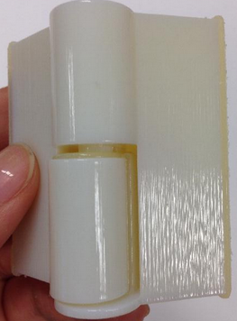 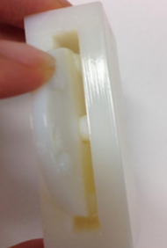 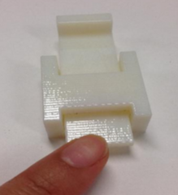 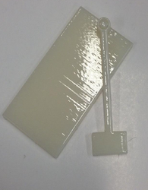

**Figure 3. Four types of 3D moving primitives, (a) hinge, (b) spinner, (c) pulley, and (d) sway**

# Related works

3D printing has risen up a promising method for helping parents to replicate tactile books and share designs via online community. [Kim] These tactile pictures books printed in 3D help children with visual impairment develop emergent literacy, by coreading the book with their parents and teachers along with the 3D printed context of each page. [Stangl] They create unique spoken stories according to children’s interests since every kids are unique. Since 3D printing reduce Jie qi et al [Ref] found adding movable and interactive objects on children book drags children’s curiosity. Physical interaction triggers by push and pull, or spinning attracted children’s interests into the book. However, there is limitation that those interactions gives visual feedback, turning on and off lights, that visually impaired children are not able to see.

# METHOD

The system consist of front end user interface that takes two pictures of 2D visuals from children book, and generates a ready to print STL files. Users

## Define Moving Primitives from Two Pictures of Input

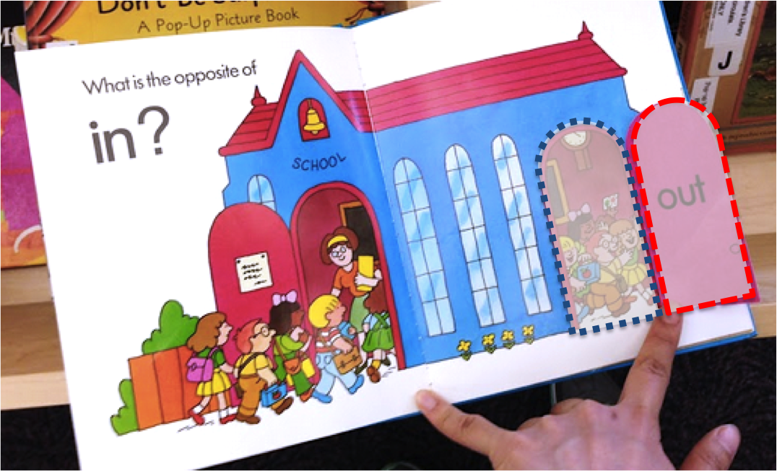 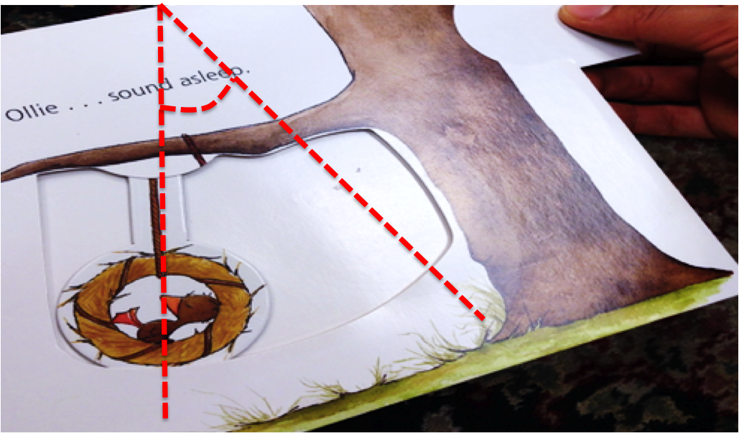 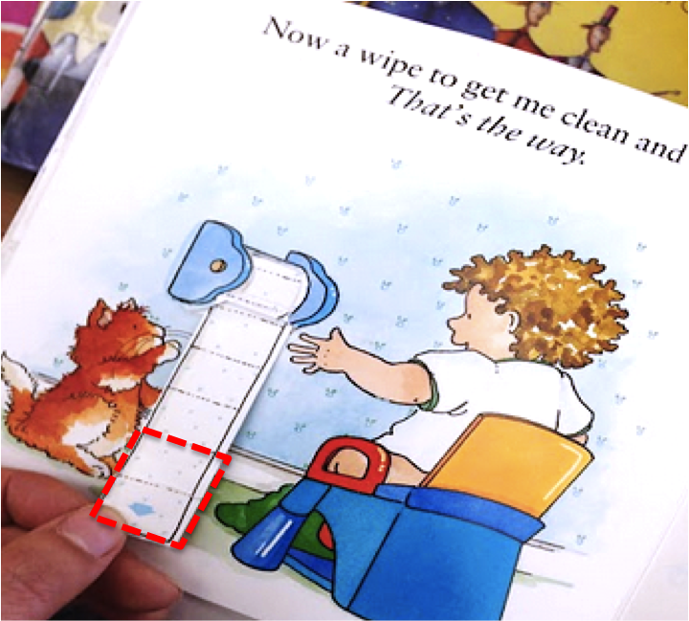

**Figure 4. (a) Left shaded area is newly come out, by being taken out right shaded area of long dashes that will be taken as movable part. (b) A part of picture in different position in angle is defined as swing or spinner.** (c) how is pulley defined?

Our system takes two pictures of the page which is movable, in order to consist two layers of each page. The interaction type, moving primitive type in this case, is defined by image processing of these two input pictures.

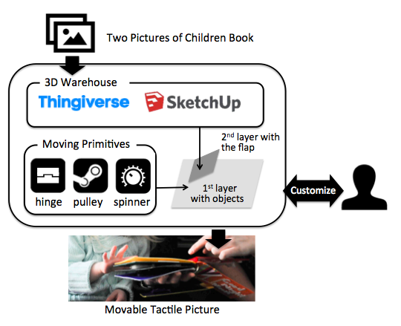

**Figure 5. The system takes two pictures as input, generate 3D printable moving-tactile picture file.**

From (a) in Figure 4, a small part of rounded rectangle in the first input scene is gone, and this shape is replaced with a new image,in the second input scene. This specific shape is cut off from the first picture and be a second layer of flapping part, and the medium values of two images, combination of (1) newly replaced part of second picture, children inside the door in this particular example, and (2) the entire school house image from the first input image become a first layer of tactile page. If same image is rotated, being shown in different position of in certain angle, this is translated in sway or spinner. Basic mechanism of defining a movement type works either for sway and spinner, since both movements similar but in different angle. If the limit of rotation is given or the angle of rotation is greater than given threshold, it will be defined as spinner, rather than sway.

## Interactive Customization of Tactile Page

In the basic mode of system, users already get a ready-to-print 3D model. Once 2D visuals as input are scanned, objects which will be put on first layer are searched from online 3D warehouse such as Thingiverse [Ref], SketchUp [Ref] where a lot of practitioners, designers, and hobbyists share their professional 3D designs. Parents and TVIs do never need to design complicated and detailed real life objects. Among tons of designs in different shapes, various abstraction level of detail, etc., they only need to choose the best fitting model to import in the design. By checking appropriate sizes of the objects, users define position of object, reduce or increase the number of object placed elsewhere to add details of scene, resize model interactively. In more sophisticated mode, users can choose the perspective views of the object. For example, in one version of 3D tactile picture, the side view of a bed can be embodied, otherwise, the bottom side of the bed view can be depicted for another version of Figure 2.

## Generate Ready to Print STL Files

We developed OpenSCAD code generator that imports STL models searched from the URL using “thing number”, which is unique ID of every single 3D model in Thingiverse. The position, size and kinds of objects from warehouse and including moving primitives are adapted to our code generated as given parameter. Size of parameter defines the general scale of components, and this parameter automatically defines how much the model should be flatten to fit in volume. The system also verifies the model downloaded from warehouse is printable, manifold. Finally, the system renders the entire models, and generates ready to print STL file of the tactile picture.

# Results

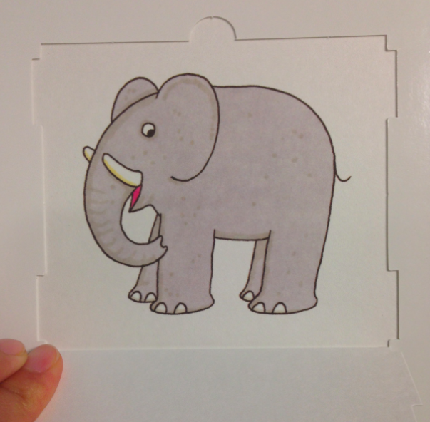 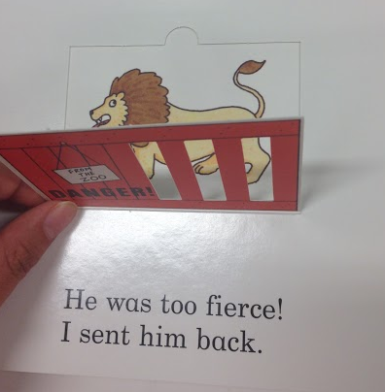 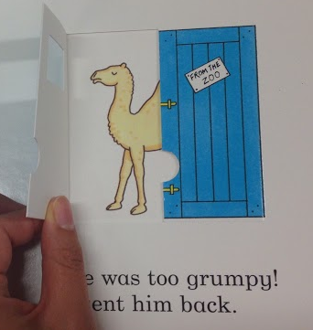 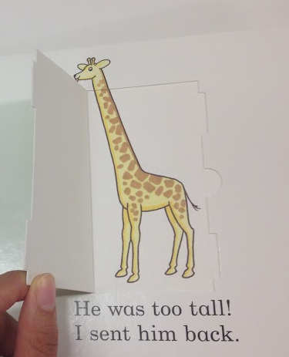 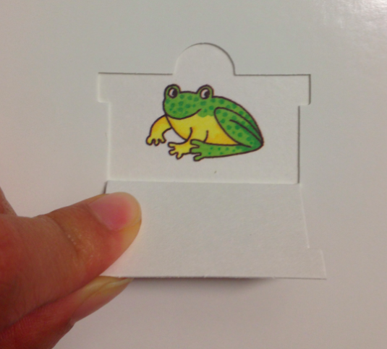 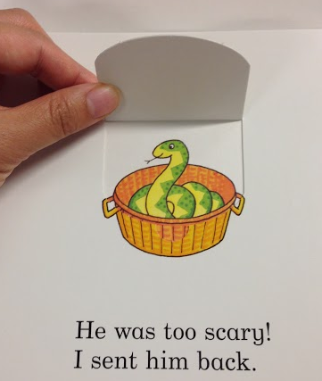 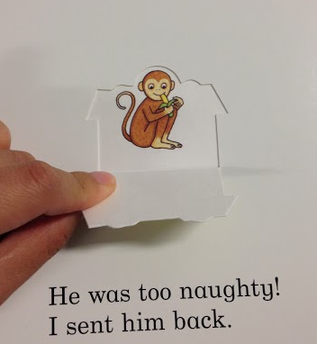 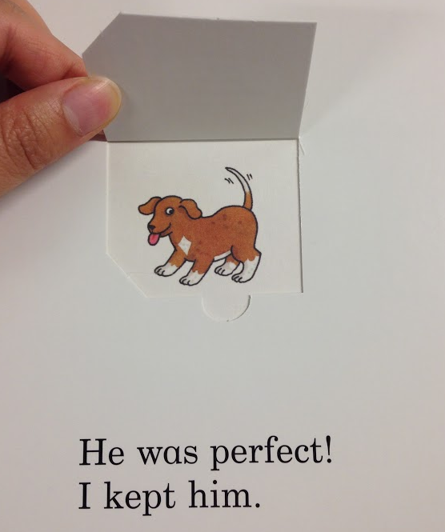

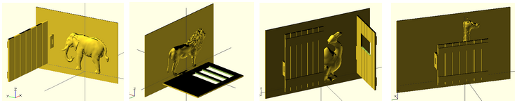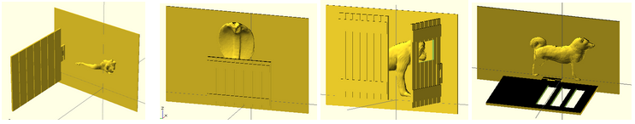

**(a) Elephant with one fence door flapping left (b) Lion with door with ribs flapping down   (c) Camel with two doors with window in the middle fliapping in two direction (d) Giraffe with a lower door showing its head over the door** **(e) Frog with one door, (f) snake head above a lower door, (g) monkey with two direction door, and (f) dog with flap down door**

**Figure 6. Eight different animal pictures with flap part of “Dear Zoo” (above) and movable tactile representation (below)**

**Repetition of One Primitive with the Entire Book**

We transcribed the *Dear Zoo* into 3D movable tactile pictures book, as a whole set of the picture book. The story is focusing on very simple conception of the kinds of animal children can see from the zoo, and 2D visuals of them emphasizes features of each animal in terms of size. This is a good example book to be tested by our system, since the *Dear Zoo* is one of the most loved lift-the-flap books that manipulates simple interaction mechanism repetitively such as opening the boxes. For our users, parents need only differentiate the kinds of animal and size of the box. Optionally, the kinds of the door, which is done by changing various doors with different hinge position, lets their children to open the door in different directions. Figure 5 shows eight pages of animal with flap from the book and 3D representation of each page. Figure 5 shows eight pages of animal with flap from the book and 3D representation of each page.

## Applications of Primitives with Different Books

**Hinges**

Traditionally, the door of house is the most common objects used for lift-the-flap book. Connection between doors and walls by hinge primitives are defined by two pictures of closed visual and opened visual. This is also applicable for any flapping objects, such as flag(a), cloud(b), and sail. Both tip of hinge primitive are combined to the dowel and flags in (a) of Figure XX, to represent flag’s movements in windy whether. For the second example of hinge, the back

of cloud hiding rocket was combined with flames to transcribe a new scene when the flap is opened, that rocket exhumes flames. The hinge of the second application is printed separately, and fabricated to the cover like LEGO, to avoid print fail because of complexity.

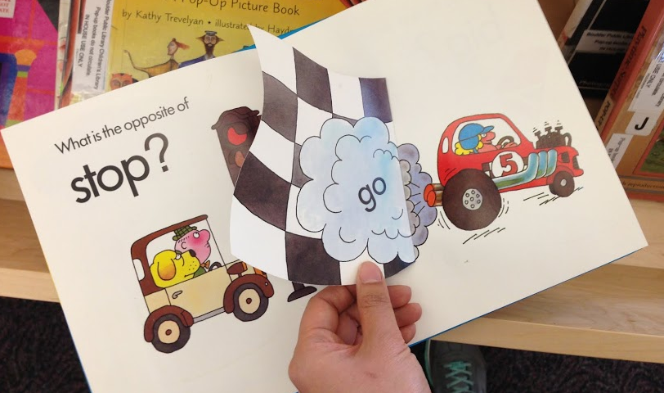 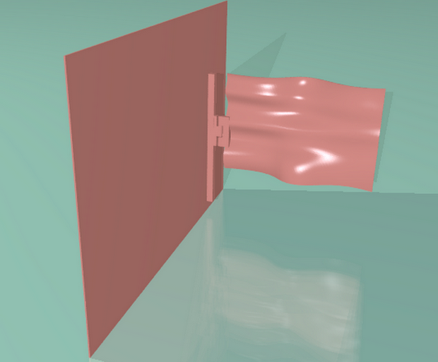

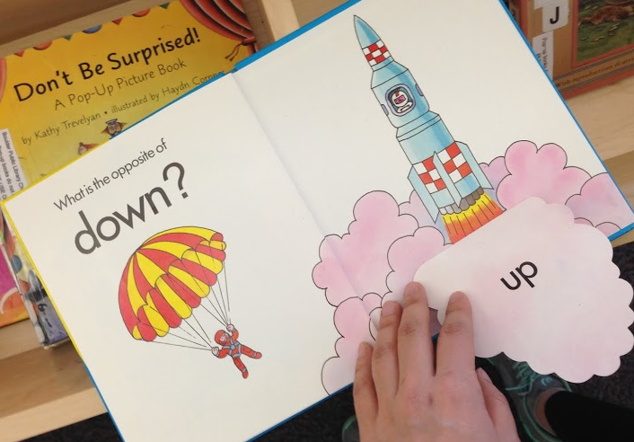 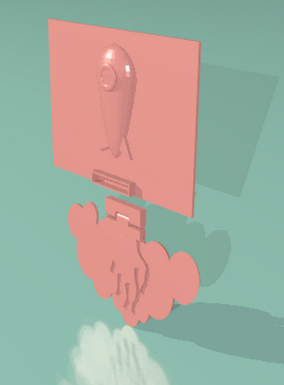

**Figure 7. A flag combined with hinge to flap (above) and a rocket beneath the cloud (below)**

**Spinner**

The most salient feature of roller is spinning attribute. This primitive is able to be adapted to tires of a car running over street, a giant wheel in an amusement park. For those young children who has never seen ferris wheel, it will be hard to understand how car is moving (a), how giant wheel is rotating from ***All the Fun of the Fair*** (b). To be adapted as part of movable objects, roller was scaled down and copied to be integrated two tires. Roller was maximized the size to fit into large frame of a giant wheel in the second example. Parents and teachers co-read the story and children with visual impairments can touch and feel cylinder with a hole is moving around an axe, and they may interact following narratives. Numerous application ideas will rise, such as lids of a jar, LP record panel spinning over gramophone.

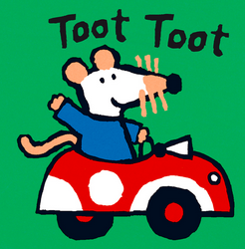 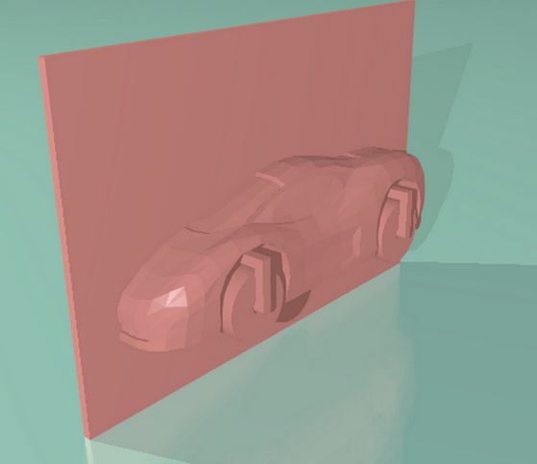

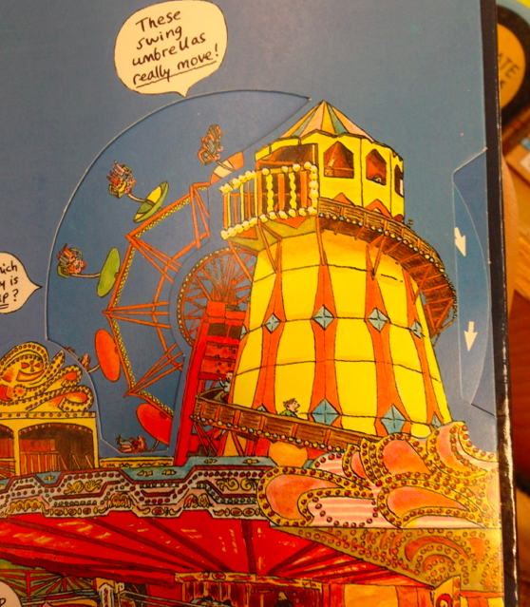 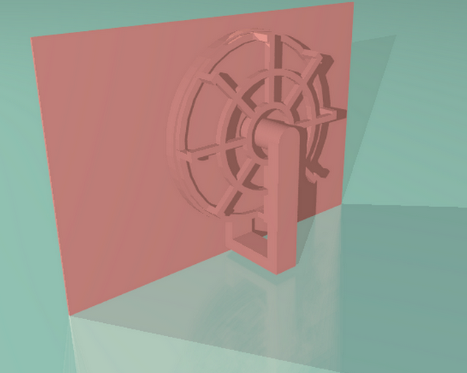

**Figure 8. Two examples of roller application, A car from with rolling wheel (above), and a giant wheel with rolling axes (below). According to the angle of rotation, examples can be combined with swing.**

## Pulley

Pulley is one of most versatile primitive to be adapted to any kinds of interaction. The pulley, as a part mechtronics, can trigger movements of the picture in any direction, with any shapes. From (a) of ***[Title]***, in Figure XX, the pulley is also connected to toilet paper to present the paper is rolling down. Also, (b) of ***Maisy Series*** book, the pulley is fabricated to the juice, to present the rest amount of juice in the glass. As the mouse drinks over the juice, children pull down the tip of pulley, by touching and feeling decreasing amount of juice. User also can imagine the slide, train that move through trails that lead visually impaired children feel mobility of those objects.

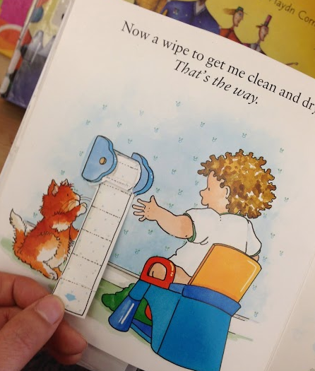 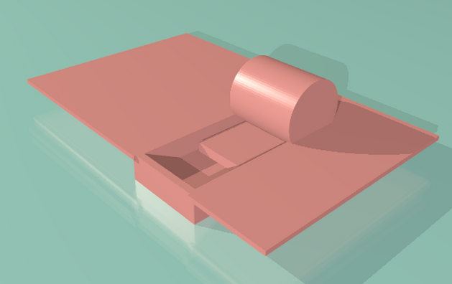

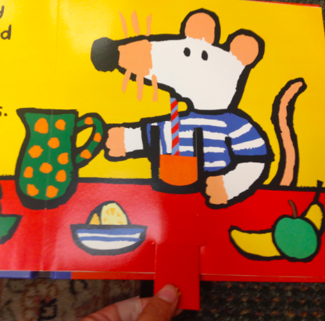 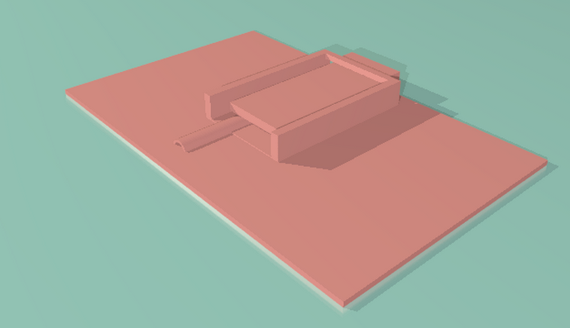

**Figure 9. Two examples of pulley primitives. A toilet paper turns out from a roll (above), and juice in the glass that reveals straw according to pulling (below)**.

# User study

We invited a mid-level expert of 3D design to explorer page variations of “Dear Zoo” book. We gave a parameter of (1) kinds of animal choice, (2) size of animal, (3) size of the door, and (4) kinds of door. He chose animals based on selection criteria, shapes and complexity of the model. Even though the animal design from online 3D warehouse looks good, if the model is too high poly, he changed his selection because it takes too long to re-render from OpenSCAD generator to get final STL file to print out. He changed the door size widely for the frog model, to fully cover the frog on the page when the flap is closed. In the same way, he scaled animal size to fit in given page back size, neither too big, nor too small, considering tactility of touch. Basically he randomly applied kinds of the door, but changed the design into side opening door if scaled animal design is too tall so that down hinge is overraped with animal’s legs.

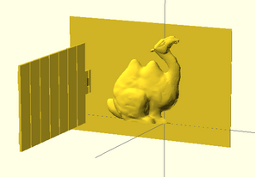 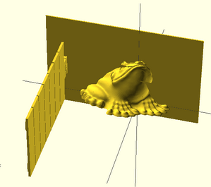 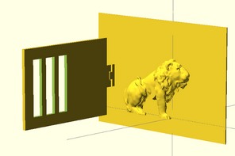 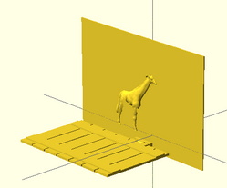

**Figure 9. Four variations of animal with different design, size, and door types.**

# Conclusion

It is important that you write for the SIGCHI audience. Please read previous years’ *Proceedings* to understand the writing style and conventions that successful authors have used. It is particularly important that you state clearly what you have done, not merely what you plan to do, and explain how your work is different from previously published work, i.e., what is the unique contribution that your work makes to the field? Please consider what the reader will learn from your submission, and how they will find your work useful. If you write with these questions in mind, your work is more likely to be successful, both in being accepted into the Conference, and in influencing the work of our field.

# REFERENCES

1. Jie qi, Leah Buchery, Electronic Popables: Exploring Paper-Based Computing through an Interactive Pop-Up Book, TEI 2009
2. Kim J., Stangl A., Eisenberg A., Yeh T., Tactile Picture Books for Young Children with Visual Impairment, TEI 2014
3. Lipson H, Kurman M, Fabricated: The New World of 3D Printing p.271-275
4. Stangl A., Kim J., Yeh T., Technology for emergent literacy, IDC 2014
5. Google SketchUp 3D Warehouse https://3dwarehouse.sketchup.com/
6. MakerBot Thingiverse http://thingiverse.com
7. Go, Maisy, go!
8. Goodnight Moon
9. Harold and Purple Crayon
10. All the Fun of the Fair
11. Eric Hill, What’s the opposite?
12. Dear Zoo
13. Oliver Dunrea, Gossie Playes Hide and See